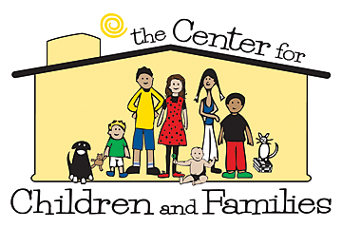
TransPARENTING
Helping Parents & their Children Cope with the Painful Transitions of Divorce, Separation and Never Married families
3021 3rd Avenue North, Billings, MT 406-294-5090 www.forfamilies.org
Special Notice to Parents Registered for the TransParenting Class
TransParenting is an educational program designed to teach effective parenting during and after the transitions of divorce or parental separation. It impresses upon parents the critical role they play in their child’s ability to adjust to changes in family situations and ‘serves to lessen the negative effects of parental separation and divorce on children’. This class is designed to meet the needs of court mandated referrals. See www.transparenting.com
A partnership with a free web based education tool, www.UpTo Parents.org, is meant to offer parents additional insight through online work. You are encouraged to visit this site prior to your scheduled class and complete through Exercise 3.
WHAT: One time, four hour parent education class that will teach, validate and reinforce how you can help yourself and your child(ren) through this painful transition.
WHERE: The Center for Children and Families, 3021 3rd Avenue North, Billings, MT **Please Enter on the West side single door on 31st Street (Self Help Law Library door)
WHEN: Classes held the third Saturday of each month (8:30 a.m. to 12:30 p.m.) and the first Tuesday of each month (5:30 to 9:30 p.m.)
COST: The cost of the class is $75 (single) and $100 (couple). Pre-pay is required at The Center for Children and Families (cash, money order, check, debit/credit card)
Pre-Registration Required: The Center for Children & Families at 294-5090 Saturday class schedule: (2015) 4/18, 5/16, 6/20, 7/18, 8/15, 9/19, 10/17, 11/21, 12/19 Tuesday class schedule: (2015) 5/5, 6/2, 7/7, 8/4, 9/8, 10/6, 11/10, 12/1
You pre-registered, for the TransParenting class on:________________________
Please give 24 hour notice (294-5090) if you are not able to attend your scheduled class.

